

Programming

**Project Documentation**

Teacher: Marcin Jagiela

Students: Kudakwashe Nyamutsaka, Takunda Kadyautumbe, Brendon Nyavira

ID: w67040, w66973, w66971

Rzeszów 2024

TABLE OF CONTENTS

* CODE USED
* HOME PAGE
* PRODUCTS PAGE
* ABOUT US PAGE
* CONTACTS PAGE
* PRODUCTS DETAILS PAGE(s)

**Description of topic, and objectives**

**CODING**

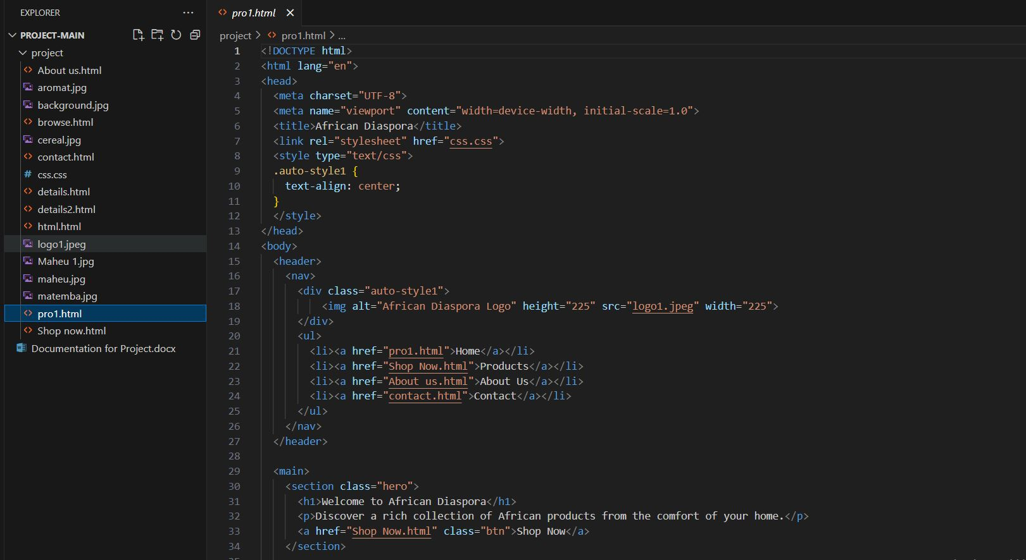

Fig.1

So the imagine above shows coding that was used when designing the website. The image contains code used in the home page and as you can see there are multiple links that allow the page to be linked to the other webpages used in creating the website. The codes can be seen on the left hand side of the image. There are also images that were used in creating this webpage and just like the codes they are shown on the left hand side of the above image. There is also the link that attaches the style sheet that we used when creating the webpage.

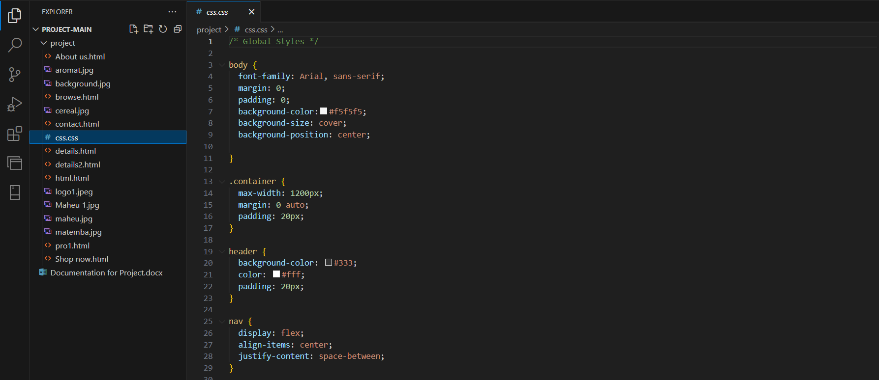

Fig.2

This image just basically shows how the webpage has been styled using this style sheet. The style sheet is basic and basically adds the different things to the webpage such as font and spacing. The font will be applied to the body of the webpage and things like headers have already been set in the initial code for the webpages.

**HOME PAGE**

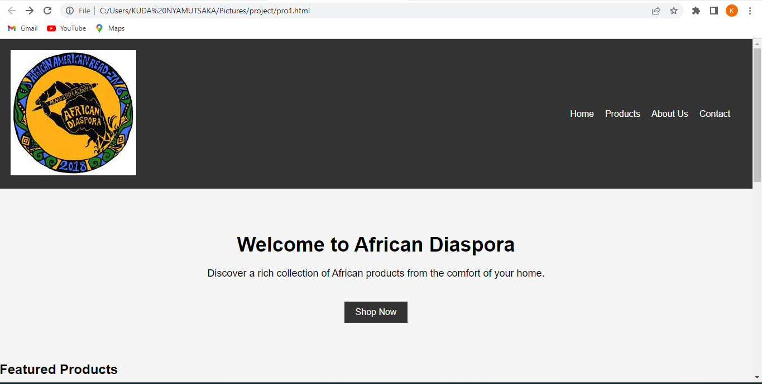

Fig.3

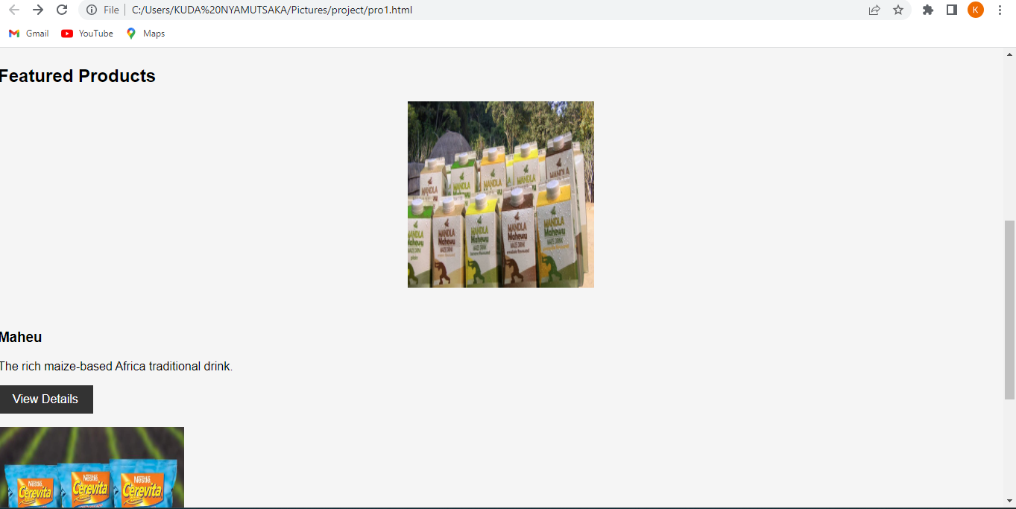

Fig.4

The above images basically just display the home page of the website. As shown in Fig.3 there is the website name and it shows the navigations to each section of the webpage. So upon clicking each navigation it will open there required page.

**PRODUCTS PAGE**

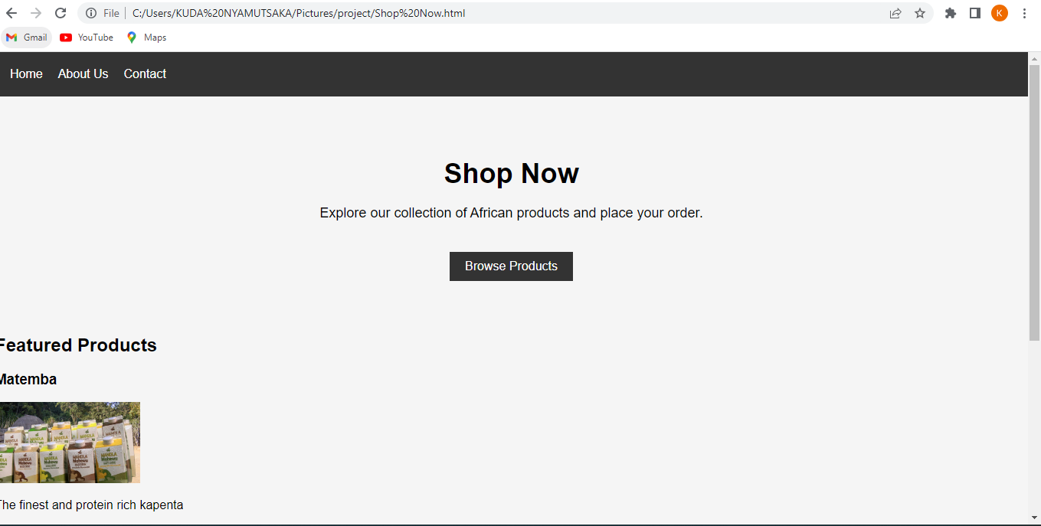

Fig.5

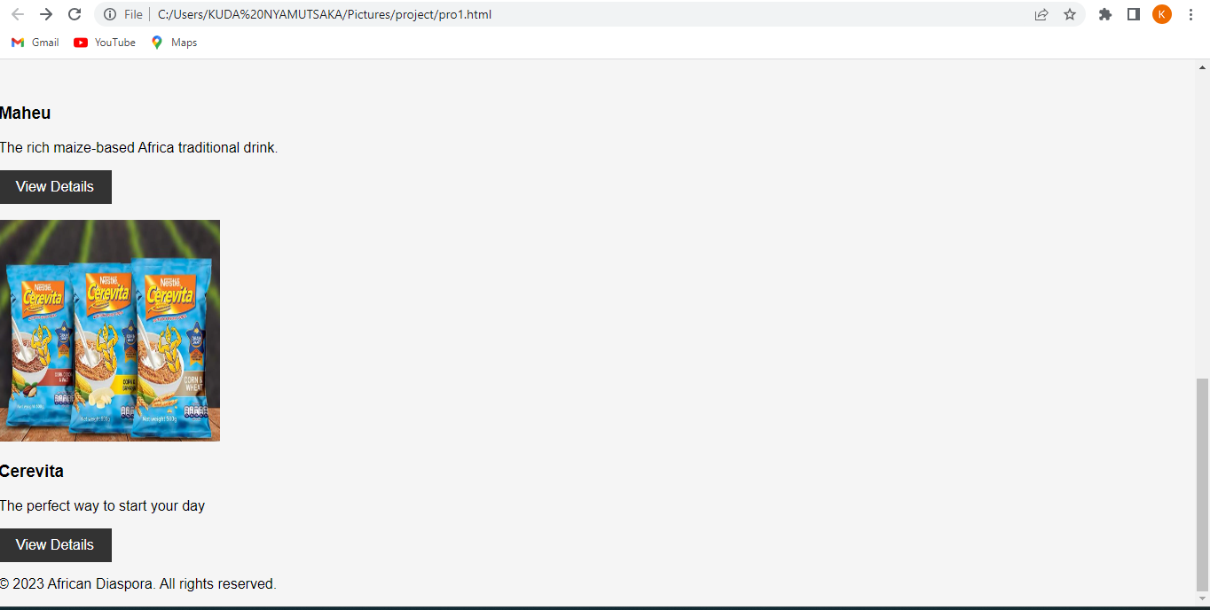

Fig.6

This is the page where customers can select all the products they are offering to purchase by viewing the product details and adding to cart if desired.

**PRODUCT DETAILS PAGE(s)**

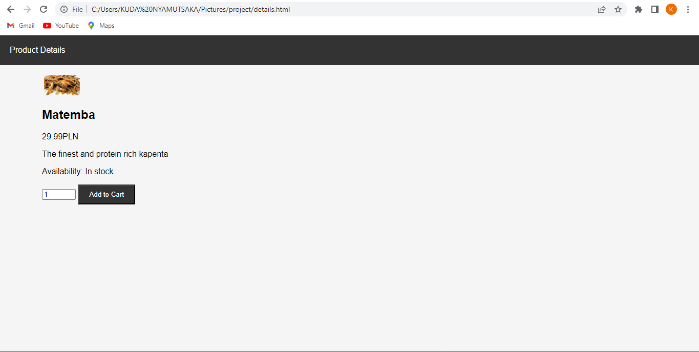

Fig.7

This page gives a short description of the product selected and gives option to add to cart.

**ABOUT US PAGE**

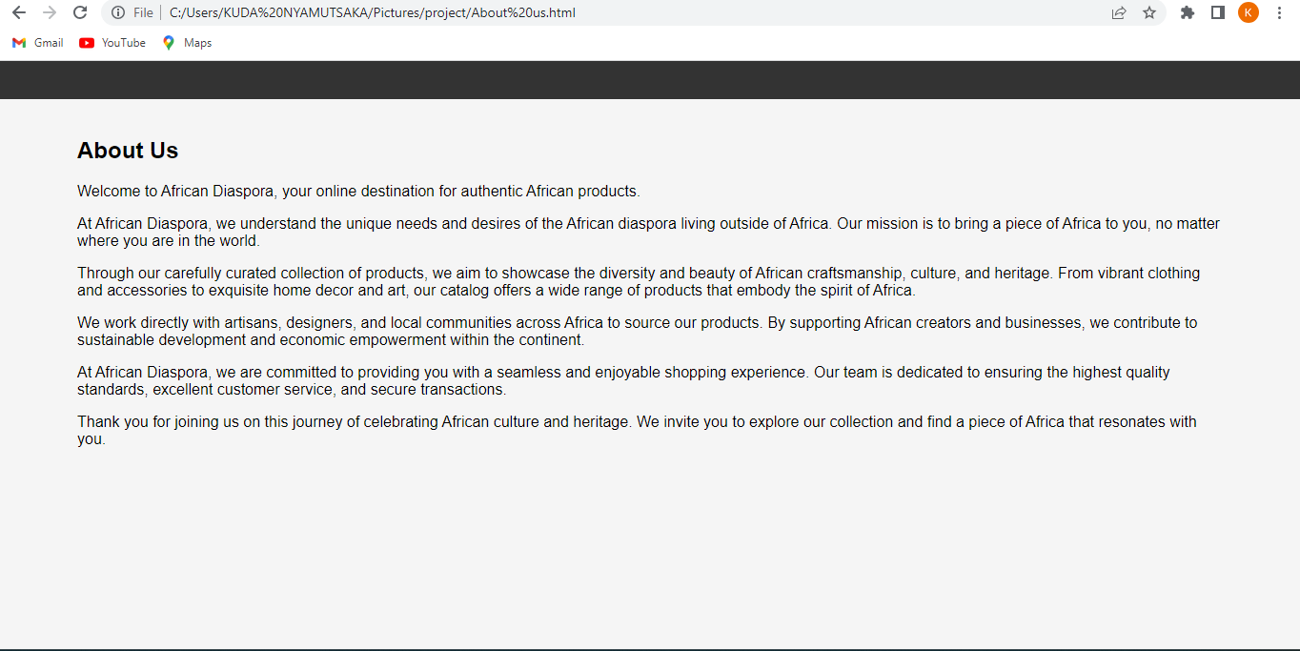

Fig.8

This page generally describes the aim of the creation of the website.

**CONTACTS PAGE**

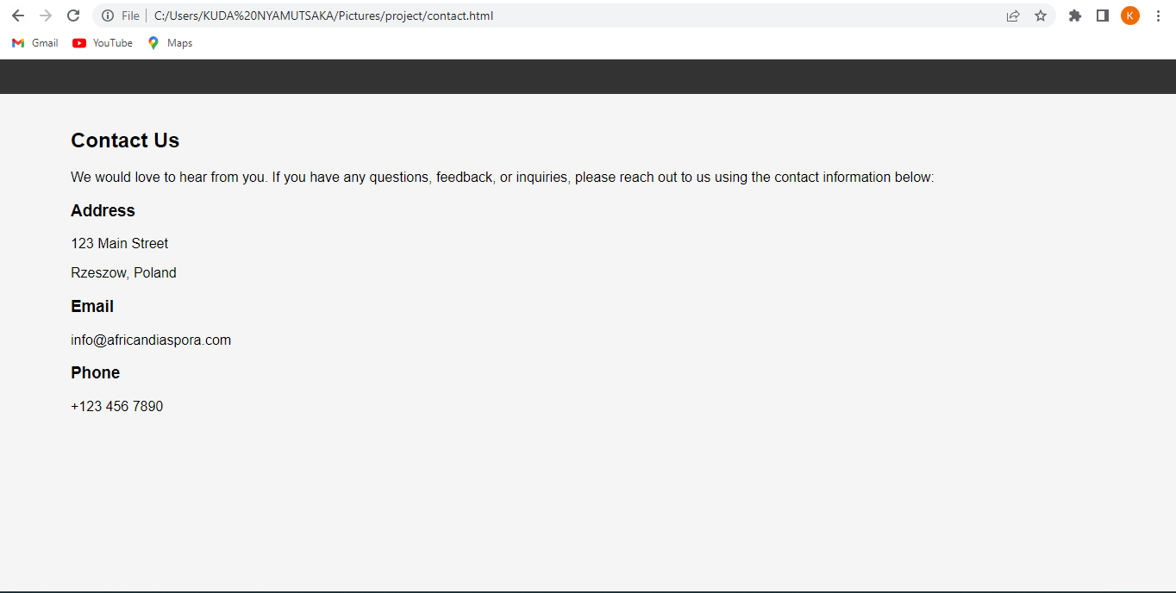

Fig.9

This page gives contact information for the African Diaspora team that will help and answer any questions about their products and website.

## DESCRIPTION OF THE TECHNOLOGIES USED

**LITERATURE**

* The website has a logo of "African Diaspora" displayed in the header section.
* The navigation menu consists of four links: Home, Products, About Us, and Contact.
* The main content is divided into two sections: a hero section and a product grid section.
* The hero section contains a heading, a brief description, and a call-to-action button to "Shop Now."
* The product grid section showcases featured products with their respective images, names, descriptions, and a "View Details" button for each product.
* The footer section includes a copyright notice with the year and the name "African Diaspora."